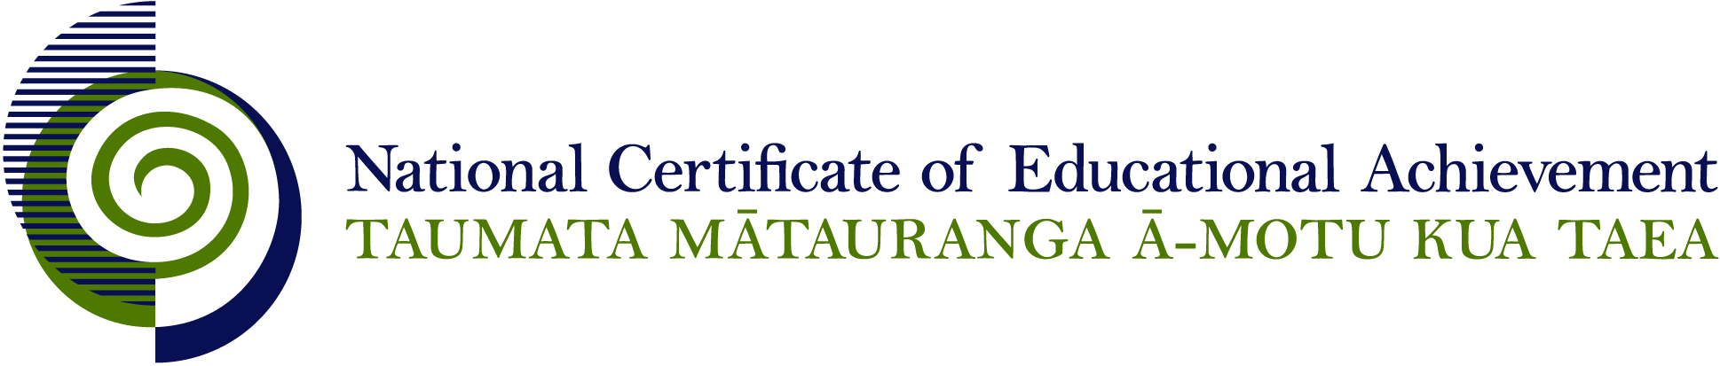

NCEA Level 3 Visual Arts

Conditions of Assessment

General Information

Subject Reference | Visual Arts
Domain | Practical Art
Level | 3

Conditions of Assessment

These Conditions provide guidelines for assessment against internally assessed Achievement Standards. Guidance is provided on:
- specific requirements for all assessments against this Standard
- appropriate ways of, and conditions for, gathering evidence
- ensuring that evidence is authentic.

Assessors must be familiar with guidance on assessment practice in learning centres, including enforcing timeframes and deadlines. The NZQA website offers resources that would be useful to read in conjunction with these Conditions of Assessment.

The learning centre’s Assessment Policy and Conditions of Assessment must be consistent with NZQA’s Assessment Rules for Schools with Consent to Assess. This link includes guidance for managing internal moderation and the collection of evidence.

Gathering Evidence

Internal assessment provides considerable flexibility in the collection of evidence. Evidence can be collected in different ways to suit a range of teaching and learning styles, and a range of contexts of teaching and learning. Care needs to be taken to allow students opportunities to present their best evidence against the Standard(s) that are free from unnecessary constraints.

It is recommended that the design of assessment reflects and reinforces the ways students have been learning. Collection of evidence for the internally assessed Standards could include, but is not restricted to, an extended task, an investigation, digital evidence (such as recorded interviews, blogs, photographs, or film), or a portfolio of evidence.

Effective assessment should suit the nature of the learning being assessed, provide opportunities to meet the diverse needs of all students, and be valid and fair.

Ensuring Authenticity of Evidence

Authenticity of student evidence needs to be assured regardless of the method of collecting evidence. This must be in line with the learning centre’s policy and NZQA’s Assessment Rules for Schools with Consent to Assess.

Ensure that the student’s evidence is individually identifiable and represents the student’s own work. The evidence must be an accurate reflection of what the student independently knows and can do, according to the Standard being assessed. This includes evidence submitted as part of a group assessment, evidence produced outside of class time or without assessor supervision, and evidence produced with any use of generative artificial intelligence tools (GenAI). GenAI use should be carefully considered in the context of the Standard being assessed and its Conditions of Assessment, discussed with students before the assessment, and its use must be acknowledged. For example, an investigation carried out over several sessions could include:
- teacher guidance on the nature and extent of acceptable GenAI use, if any
- assessor observations and conversations
- meeting with the student at set milestones or checkpoints
- the student’s record of progress, such as photographic entries or any GenAI prompts used.

Specific Information for Individual Internal Achievement Standards

Achievement Standard Number | 91440 Design 3.1  91441 Painting 3.1  91442 Photography 3.1  91443 Printmaking 3.1  91444 Sculpture 3.1
Title | Analyse methods and ideas from established design/painting/photography/printmaking/sculpture practice
Number of Credits | 4
Version | 1

Evidence may be presented by the student in a range of forms, including:
- written notes or paragraphs
- annotated drawings, photocopies, and diagrams
- oral presentations
- data display presentations
- audio recordings
- visual recordings.

Students must use their own words to present evidence for this standard.

It is recommended that research sources are acknowledged.

Achievement Standard Number | 91445 Design 3.2  91446 Painting 3.2  91447 Photography 3.2  91448 Printmaking 3.2  91449 Sculpture 3.2
Title | Use drawing to demonstrate understanding of conventions appropriate to design/painting/ photography/printmaking/sculpture.
Number of Credits | 4
Version | 1

Evidence may be submitted in a range of modes, including:
- Hard copy
- Digital still image
- Digital moving image
- 2, 3, or 4 dimensional
- Audio visual.

Achievement Standard Number | 91450 Design 3.3  91451 Painting 3.3  91452 Photography 3.3  91453 Printmaking 3.3  91454 Sculpture 3.3
Title | Systematically clarify ideas using drawing informed by established design/painting/photography/ printmaking/sculpture practice.
Number of Credits | 4
Version | 1

When referring to established practice a range of examples of artworks should be referenced with regard to the genre, style, convention, or way of working.

Evidence may be submitted in a range of modes, including:
- Hard copy
- Digital still image
- Digital moving image
- 2, 3 or 4 dimensional
- Audio visual.

Achievement Standard Number | 91460 Visual Arts 3.5
Title | Produce a resolved work that demonstrates purposeful control of skills appropriate to a visual arts cultural context
Number of Credits | 4
Version | 1

Contexts for this standard may include:
- Collaborative projects
- Site specific work
- Installation
- Marae based practices
- Time based practices.

Where collaborative or group projects are undertaken strategies need to be developed to facilitate the assessment of individual learners. This may include:
- Designated roles and/or parts within a group project
- A tracking system to monitor individual contributions, e.g. a log of teacher observation
- Teacher observation and teacher/student conferencing can be used to verify individual student’s contribution to the collaborative process
- Production diary noting individual contributions to the project
- Peer assessment, used in conjunction with teacher input
- Limiting group numbers, depending on the context.

Evidence may be submitted in a range of modes, including:
- Hard copy
- Digital still image
- Digital moving image
- 2, 3 or 4 dimensional
- Audio visual.

